Table of Contents

**Problem Statement** 2

**Industry/Domain** 2

**Stakeholders** 2

**Business Question** 2

**Data** 2

**Data Science Process** 2

**Data Analysis** 3

**Outcomes** 13

**Implementation** 14

**References** 16

**Problem Statement**

* **Prevalence of Fraudulent Reviews**: The online marketplace is filled with fake reviews that mislead consumers, making it difficult to trust product and service ratings.
* **Impact on Consumer**: Consumers rely on reviews for purchasing decisions; fraudulent reviews can lead to dissatisfaction and damage brand reputation.
* **Financial Losses for Businesses**: Review fraud results in decreased sales and increased returns, leading to significant financial impacts on businesses.
* **Challenges in Detection**: Detecting fake reviews is difficult due to sophisticated tactics used by fraudsters, making existing detection methods inadequate.
* **Regulatory Compliance Risks**: With increasing regulatory scrutiny, businesses risk legal penalties if they fail to manage review authenticity properly.
* **Erosion of Brand Trust**: Fraudulent reviews erode consumer trust in brands, affecting customer loyalty and long-term sales.
* **Insufficient Review Management Tools**: Many businesses lack effective tools to monitor and manage reviews, hindering their ability to combat fraud

**Industry/Domain**

E-commerce and Online Retail.

**Stakeholders**

* **Consumers**: Rely on authentic reviews to make informed purchasing decisions, influencing their choices and satisfaction.
* **E-commerce Platforms**: Strive to maintain credibility and trustworthiness among users by ensuring the authenticity of reviews, which is crucial for their business model.
* **Businesses and Brands**: Aim to protect their reputation and minimize financial losses caused by fraudulent reviews, as these can directly impact sales and customer loyalty.
* **Review Platforms**: Require effective systems to monitor and manage review authenticity, ensuring their platforms remain reliable for users and businesses alike.
* **Regulatory Authorities**: Focus on enforcing fair practices and protecting consumers in online markets, emphasizing the importance of authentic reviews.
* **Data Scientists and Analysts**: Engage in developing and implementing fraud detection models, utilizing data-driven approaches to identify and mitigate review fraud.

**Business Question**

* What characteristics differentiate genuine reviews from fraudulent ones?
* How can machine learning models effectively classify reviews?
* What data sources are available for training these models?
* How can results be integrated into existing review systems?

.**Data Question**

* What features can best differentiate between genuine and fraudulent reviews?
* How can sentiment analysis be integrated to enhance model accuracy?
* What is the volume and diversity of the dataset required for effective model training?
* How do different types of reviews (verified vs. unverified) impact model performance?
* What are the trends in review fraud that should be monitored over time?

**Data**

* + - **Source**: The data was sourced from 9 stores, with a primary focus on Amazon.
    - **Category**: The dataset is centred around the Personal Care category, specifically covering laundry products and those under the Comfort brand.
    - **Manufacturer**: The products are manufactured by Unilever Global.
    - **Review Types:** The reviews consist of 77% Organic reviews (those posted by genuine users) and 22% Syndicated reviews (potentially collected or aggregated from third-party sources).
    - **Verified Purchase**: Each review includes a True/False flag indicating whether the purchase was verified.
    - **Market:** The dataset contains reviews from the UK market.
    - **Dimensions:** The dataset includes 1-8 dimensions related to additional product details, primarily focusing on laundry products**.**

**Data Science Process**

* **Data Collection**: Gather data from reliable e-commerce platforms.
* **Data Cleaning**: Remove duplicates, and irrelevant entries, and normalize text data.
* **Exploratory Data Analysis (EDA)**: Identify patterns and correlations in the data.
* **Feature Engineering**: Extract meaningful features (e.g., word counts, sentiment scores).

**Data Analysis**

**

Most reviews received **0 helpful votes**, indicating a lack of engagement from users in utilizing the helpfulness voting feature.

A very small percentage of reviews garnered more than **1 helpful vote**, suggesting that helpfulness voting is not a widely adopted practice among customers.

**Correlation Between Review Rating and Helpful Count**

There is a **low correlation** of **-0.05** between review ratings and helpful votes, indicating that the helpfulness of a review does not significantly relate to its rating.

This suggests that **high review ratings** do not necessarily imply that the review is considered helpful by other users, highlighting a disconnect between review sentiment and perceived usefulness.

**Distribution of Review Types**

Organic reviews are those submitted directly by customers based on their personal experience with the product.

**Percentage of Total Reviews:** **77.41%**

Syndicated reviews are sourced from external platforms and are not directly submitted by customers.

**Percentage of Total Reviews:** **22.59%**

Understanding the distribution between organic and syndicated reviews is vital for businesses and brands seeking to evaluate their reputation and the impact of customer feedback on purchasing decisions. The data suggests that while most reviews are organic, the influence of syndicated reviews cannot be overlooked, as they represent a substantial portion of the overall feedback landscape.

**Analysis of Product Categories and Subcategories with Verified Purchases (VP) data**

**Top Categories and Trends**

**1. Top Categories**

* **Homecare and Personal Care**: These categories have the highest number of reviews, indicating significant consumer engagement and interest.
* **Verified Purchases**: A substantial portion of reviews in the Homecare category comes from verified purchases, enhancing the credibility of these reviews.

**2. Subcategory Insights**

* **Laundry**: This subcategory has the most reviews, with a significant majority coming from verified purchases, suggesting a high level of consumer trust in these reviews.
* A graph with a green line

  Description automatically generated**Skin Care**: In contrast, the Skin Care subcategory shows a higher proportion of non-verified reviews, indicating potential vulnerabilities to review fraud.

**3. Verified vs. Non-Verified Trends**

* **Frequency of Verified Purchases**: Overall, verified purchases are more frequent across categories. This trend signals greater reliability and trustworthiness in the feedback provided by consumers.

**Analyzed reviews based on Verified Purchases (VP) data.**

**1. Initial Review Distribution**

* **True Reviews**: 56% of the reviews are classified as true, sourced from verified purchases.
* **False Reviews**: 44% of the reviews are identified as false, coming from non-verified purchases.A green and blue circles with black text

  Description automatically generated **Summary**: While the majority of reviews originate from actual purchasers, a notable percentage (44%) are from individuals who did not make a purchase, raising concerns about the authenticity of feedback.

**2. Impact of Amazon's Verified Purchase System**

* **Reduction of Fake Reviews**: Amazon's Verified Purchase system significantly aids in mitigating fake reviews by permitting only genuine purchasers to leave feedback. This system ensures that feedback is provided by customers who have actually experienced the product.
* **Increased Trust**: The verification process fosters greater trust in the review system, encouraging more customers to rely on reviews for their purchasing decisions.

**3. Post-Duplicate Review Analysis**

* **Review Distribution After Duplicates Removal**:
  + **True Reviews**: After the removal of duplicate reviews, the percentage of true reviews decreased to 47%.
  + **False Reviews**: The proportion of false reviews increased to 52%, indicating a slight shift in the balance.
* **Dataset Balance**: Despite these changes, the dataset remains relatively balanced between true and false reviews, suggesting that the overall integrity of the review system continues to hold despite the presence of some non-genuine feedback

**Analyzed reviews Ratings by Verified Purchases (VP) data.**

**1. Review Counts**

* **Significant Drop in Total Review Counts**: The removal of duplicate reviews results in a notable decrease in the overall number of reviews. This highlights the presence of duplicated content in the original dataset.

**2. Distribution Consistency**

* A close-up of a graph

  Description automatically generated**Proportion of True vs. False Reviews**: After duplicates are removed, the distribution of verified (true) and non-verified (false) reviews remains nearly unchanged. This indicates that duplicates do not disproportionately affect the classification of reviews.

**3. 5-Star Rating Dominance**

* **High Ratings**: A significant majority of reviews continue to exhibit high ratings (e.g., 5 stars) even after duplicates are removed. This suggests that duplicate reviews do not artificially inflate the overall ratings for products.

**4. Integrity of Ratings**

* **Preservation of Ratings Distribution**: The overall integrity of the ratings distribution is maintained. The removal of duplicates does not skew the representation of ratings.

**5. Distribution of Fraudulent Activity**

* **Even Distribution Across Ratings**: Any fraudulent activity present in the dataset appears to be evenly distributed across all rating levels, indicating that review quality is consistent across different ratings.

**Correlation for Review Analysis**

* 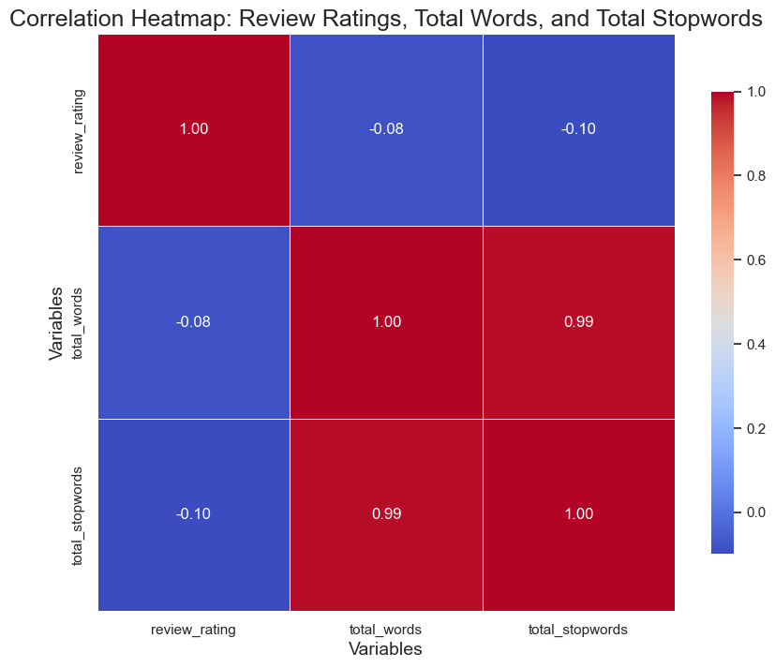**Review Ratings**: This variable serves as an indicator of customer satisfaction. Higher ratings typically reflect better experiences and satisfaction levels among consumers.
* **Total Words**: Represents the total number of words contained in each review, providing insight into the length and detail of customer feedback.
* **Total Stop Words**: Counts the number of common, less significant words (e.g., "the," "is," "at") in each review. These words often do not contribute meaningfully to the content of the review.

**2. Heatmap Purpose**

The heatmap visually represents the strength and direction of relationships between the variables mentioned above. It helps identify potential correlations that may inform further analysis.

**3. Key Findings**

* **Strong Correlation (0.99)**:
  + **Total Words ↔ Total Stop Words**: A high correlation indicates that longer reviews tend to include more common words. This suggests that as review length increases, the frequency of stop words also rises, implying that verbose reviews may dilute the meaningfulness of the content.
* **Weak Correlation (-0.08)**:
  + **Review Ratings ↔ Total Words**: This weak negative correlation indicates that review length has little effect on ratings. Therefore, a longer review does not necessarily translate to a higher or lower rating, highlighting that quality and content may be more significant than quantity.

**Analyzed reviews Ratings by Verified Purchases (VP) data**

**Analyzed Length of Reviews on Verified Purchases (VP)**

The analysis of review lengths reveals distinct patterns between false and verified reviews. False reviews tend to have an average length exceeding 250 characters, suggesting that longer reviews may indicate inauthenticity. Fraudulent reviewers might produce lengthier content to appear more convincing or to manipulate rating systems. In contrast, verified reviews typically range from 50 to 100 characters, indicating that genuine customers provide more straightforward and concise feedback based on their actual experiences. This length analysis serves as an insightful feature for the fraud detection model, highlighting the potential for identifying dubious reviews through character count.

**Sentiment Analysis of Reviews**

The analysis of reviews reveals distinct sentiment categorizations—positive, negative, and neutral—providing valuable insights into customer opinions.

In the word cloud for positive reviews, prominent terms such as "smell," "skin," "part," and "soft" emerge, indicating the characteristics that customers appreciate most. Conversely, the word cloud for negative reviews highlights frequent mentions of words like "bottle," "one," "buy," and "disappointed," reflecting common grievances among dissatisfied consumers.

The sentiment scores, plotted on the X-axis and ranging from -1.0 to 1.0 in increments of 0.25, illustrate the polarity of reviews, with scores nearing -1 indicating high negativity, 0 representing neutrality, and scores close to 1 suggesting strong positivity. The Y-axis, representing frequency, quantifies how many reviews fall within each sentiment score range, with values spanning from 0 to 250. This comprehensive sentiment analysis not only identifies prevalent themes in customer feedback but also aids in understanding overall consumer satisfaction.

**Modelling**

1. **Model Selection**: Choose classifiers such as Multinomial Naive Bayes (MNB), Support Vector Machines (SVM), and Logistic Regression (LR), XGBoost.
2. **Vectorization**: Vectorization is a critical step in preparing text data for machine learning models in fraud detection of online consumer reviews. By choosing the right vectorization technique, we can effectively convert reviews into a numerical format that captures essential features and relationships, ultimately enhancing the model's performance in identifying fraudulent activities.
3. **Training and Validation**: Split the dataset into training and testing sets to evaluate model performance.
4. **Hyperparameter Tuning**: Optimize model parameters for improved accuracy.
5. 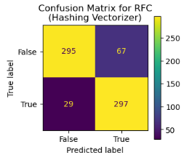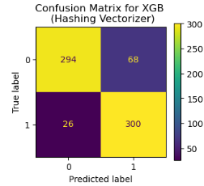**Performance Metrics**: Use accuracy, precision, recall, and F1-score to assess model effectiveness.

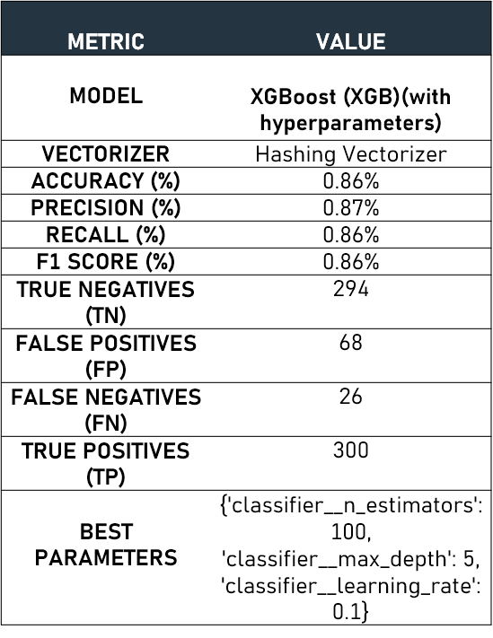

The XGBoost model, optimized with hyperparameters, provides a robust accuracy of **0**.**86%**, demonstrating its efficacy in distinguishing between fraudulent and genuine reviews. The model's precision and recall values further validate its effectiveness, indicating a balanced performance in identifying positive cases

**Outcomes**

**Model Development**:

* Successfully developed and validated a fraud detection model using machine learning techniques, primarily focusing on **XGBoost** as the best-performing model.
* Achieved an **accuracy of 0.86%**, alongside strong precision (0.87%), recall (0.86%), and F1 score (0.86%), indicating a well-balanced performance in identifying fraudulent reviews.

**Data Insights**:

* Identified that **56%** of reviews are true (from verified purchases), while **44%** are potentially false, revealing a significant presence of fraudulent activity in the dataset.
* Discovered that longer reviews (greater than 250 characters) are often associated with inauthenticity, suggesting a pattern that can be utilized in future models.

**Sentiment Analysis**:

* Categorized reviews into positive, negative, and neutral sentiments, providing valuable insights into consumer opinions and experiences with products.
* Utilized sentiment scores to gauge the overall customer satisfaction and the quality of reviews.

**Visualizations**:

* Created visual representations of key findings, such as word clouds for positive and negative reviews, which highlighted frequently used terms that characterize consumer sentiments.
* Developed heatmaps to display correlations between various review features, aiding in the understanding of relationships within the data

**Implementation**

**Integration with E-commerce Platforms**:

* + - **Deployment**: The fraud detection model can be integrated into existing e-commerce platforms, enabling real-time monitoring of reviews. This will help flag suspicious activities and automate the identification of fraudulent content.
    - **User Interface**: Create a dashboard for stakeholders to visualize review trends, model predictions, and sentiment analysis results, facilitating data-driven decision-making.

**Regular Updates and Maintenance**:

* + - Establish a schedule for regular model updates to adapt to new patterns of fraud, ensuring ongoing effectiveness.
    - Continuously collect feedback from users and stakeholders to refine the model and enhance its performance.

**Collaboration with Stakeholders**:

* + **Training**: Provide training sessions for employees and stakeholders on how to interpret model outputs and utilize the dashboard for monitoring purposes.
  + **Feedback Loop**: Create a feedback mechanism that allows users to report suspected fraudulent reviews, contributing to the model's learning and adaptation over time.

**Monitoring and Evaluation**:

* + Implement performance monitoring metrics to evaluate the model’s ongoing effectiveness in identifying fraud. This includes tracking false positive and negative rates and adjusting thresholds as needed.
  + Regularly assess the impact of the model on consumer trust and satisfaction levels, measuring changes in customer complaints and overall review integrity.

**Regulatory Compliance**:

* Ensure that the implementation adheres to relevant regulations and standards governing online reviews and consumer protection. This may involve periodic audits and compliance checks.
* Deploy the best-performing model within the e-commerce platform’s review system.
* Develop a user-friendly interface to allow consumers to check the authenticity of reviews.

**Data Answer**

**Was the data question answered satisfactorily?** Yes, the analysis identified critical features and patterns contributing to fraud detection.

**Confidence level in the data answer:** The confidence level is high, based on validation with multiple models.

**Business Answer**

**Was the business question answered satisfactorily?** Yes, the project provides actionable insights into improving review integrity.

**Confidence level in the business answer:** The confidence level is strong, supported by model performance metrics.

**Response to Stakeholders**

Stakeholders are encouraged to adopt the proposed model for ongoing fraud detection to enhance consumer trust.

**End-to-End Solution**

The developed model can be integrated into online review platforms to filter fraudulent reviews in real time, thereby enhancing user experience and trust.

**References**

* Academic papers on fraud detection techniques.
* Case studies from e-commerce platforms utilizing machine learning.
* Relevant industry reports on consumer trust and review authenticity.
* **Data and Code:** Data sources include [data source links], and the project code is available at [GitHub link].
* **Resources Utilized:** Key libraries include Pandas, Scikit-learn